Q1. I am a company.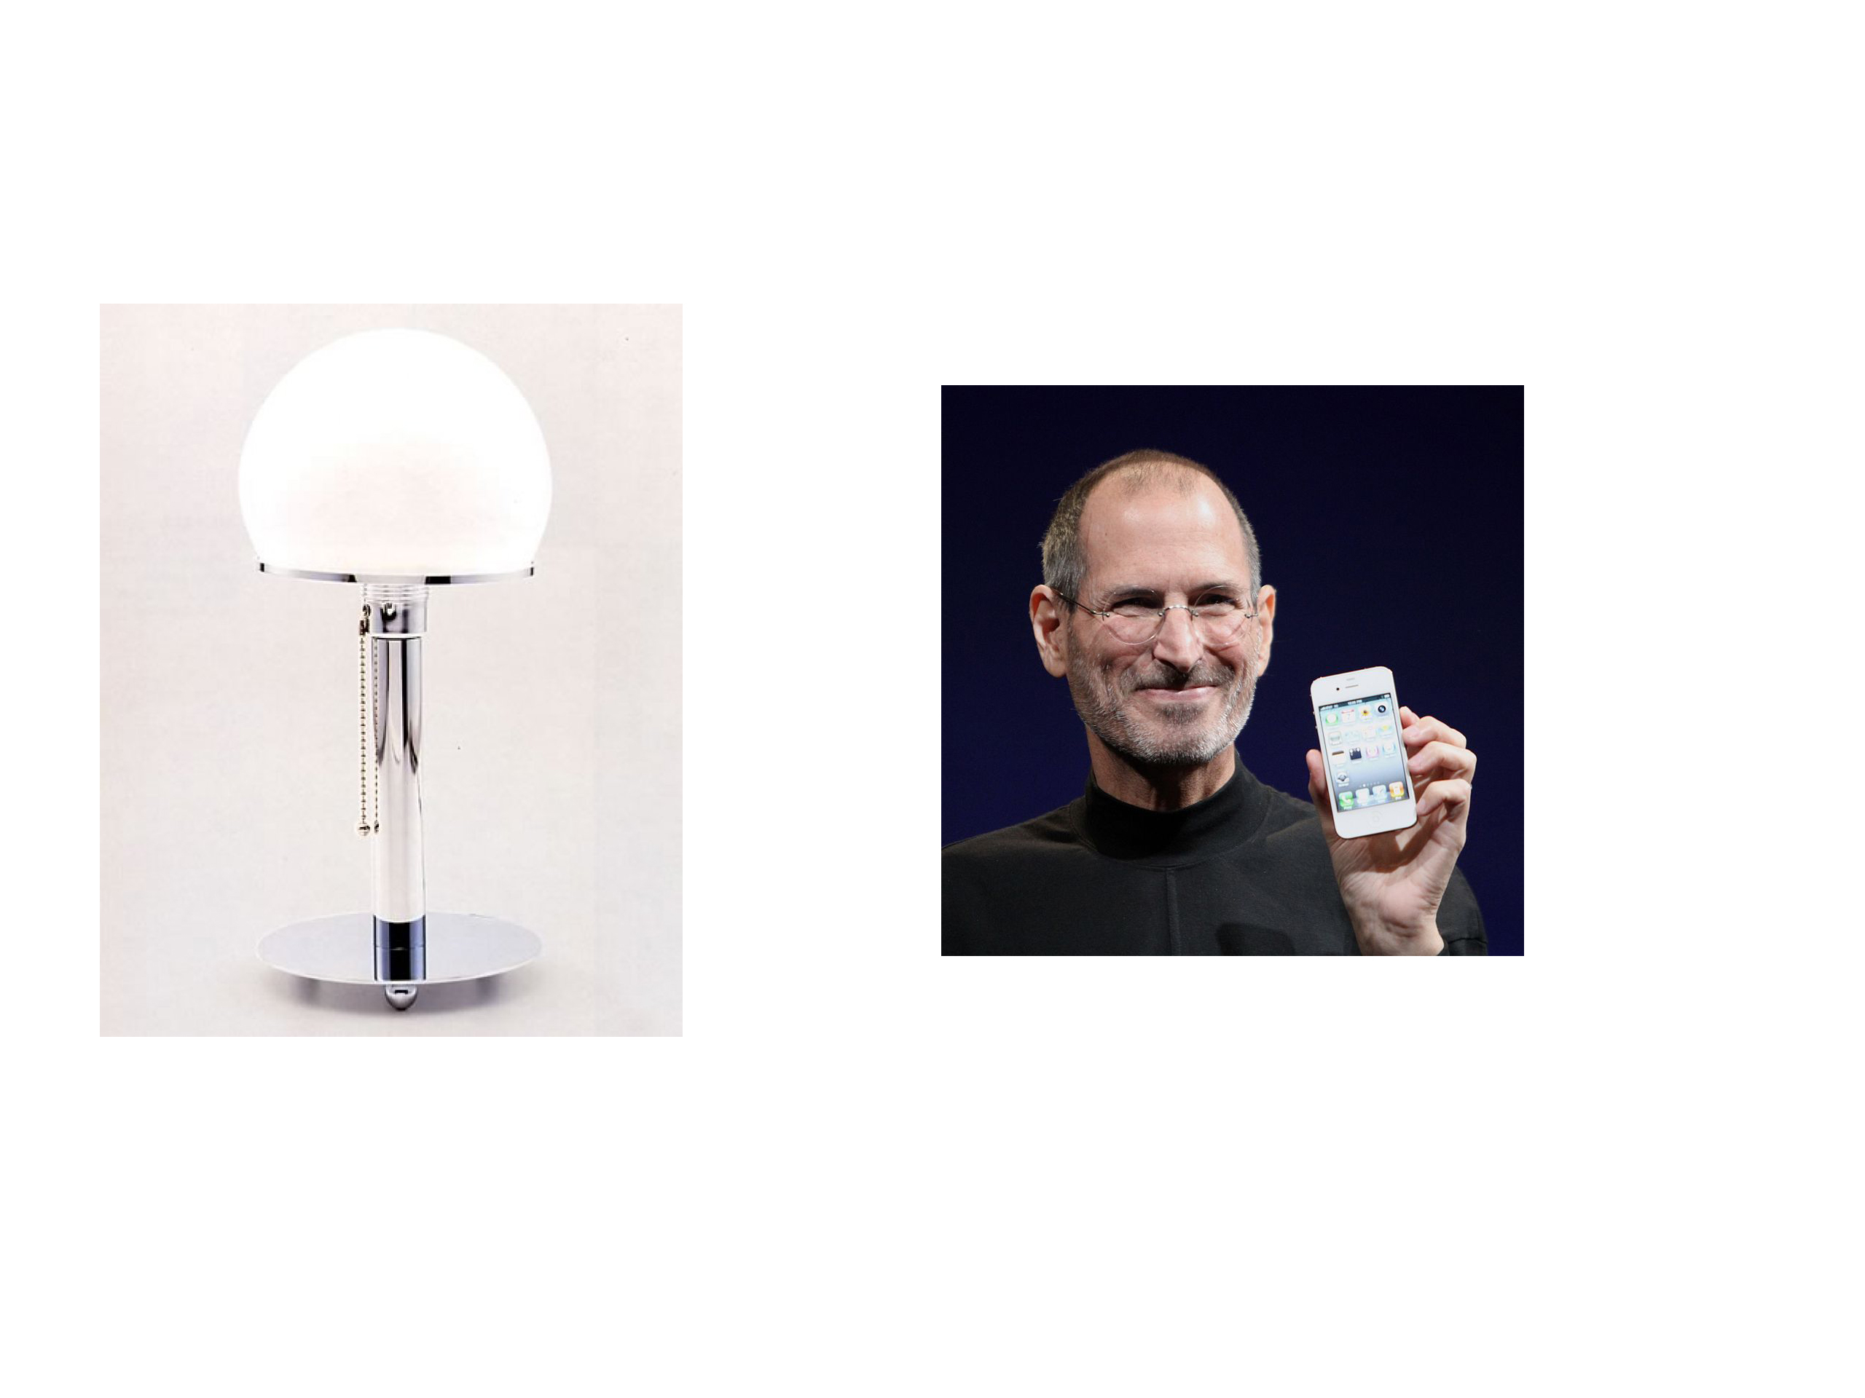

Ans - Pixar

Q2. I am city whose name is derived from a latin word whose meaning is the phenomena occurring in the city below.

Ans - Koblenz

Q3.

I am the famous indian.

Ans – Dr . Satyajit ray.

Q4. The nature of me is related to one person. The person who saved my life twice is the answer.

Ans - Alexander Flemming

Q5. 17 x 3 rectangle shows many thing. Identify me.

Ans - Dance Club.

Q6. Identify Destination?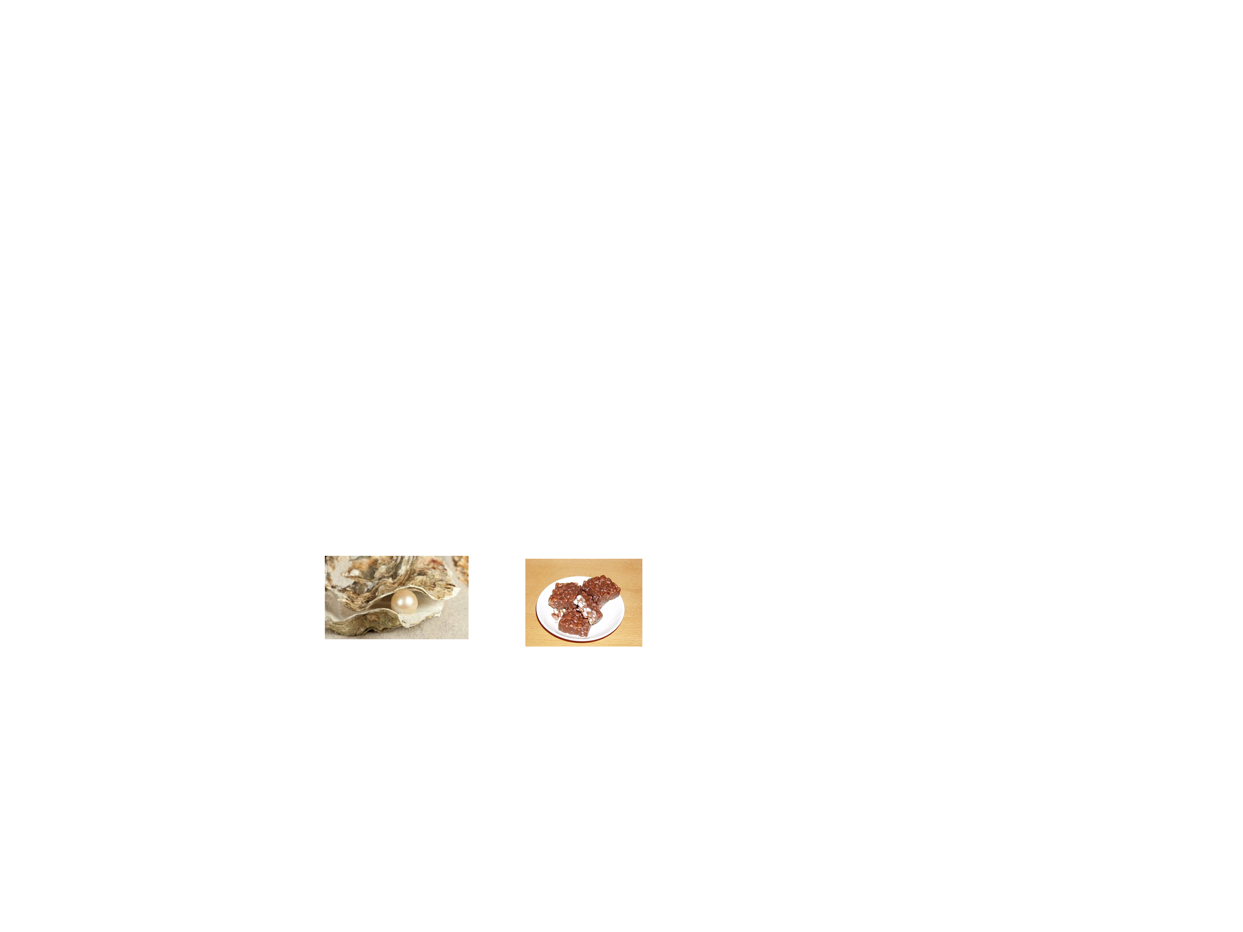

Ans - Pearl Harbour

Q4. This

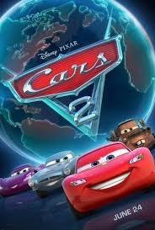

is my life and this is my death. My name is the game.

Ans. Paul William Walker IV

Q5.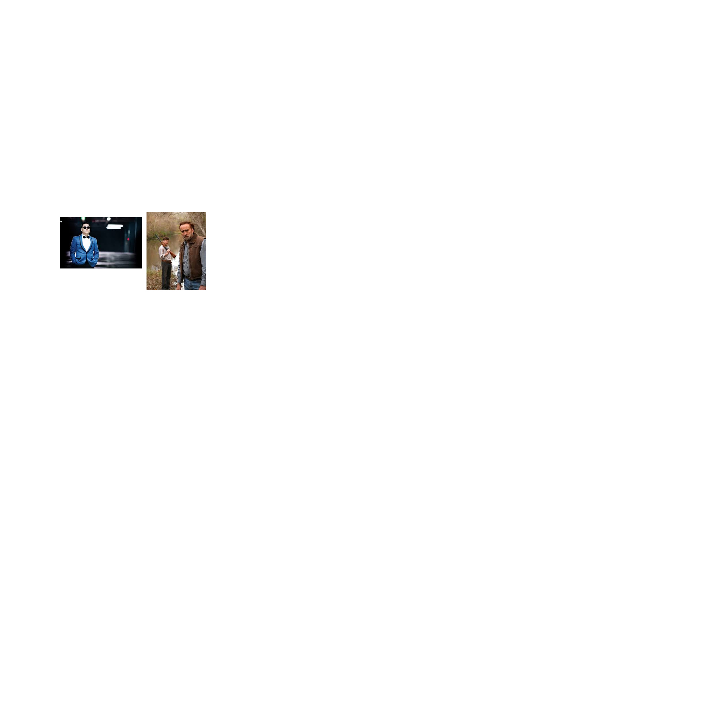 Guess my name?

Ans - Gentleman Joe